Graphing Square Root & Cube Root Functions Name___________________________
- $f\left(x\right)= \sqrt{x-2}$  a = ______ h = ______ k = ______  Reflection? ______  Vertical stretch or shrink? ____________  Horizontal shift? ____________________  Vertical shift? _____________________  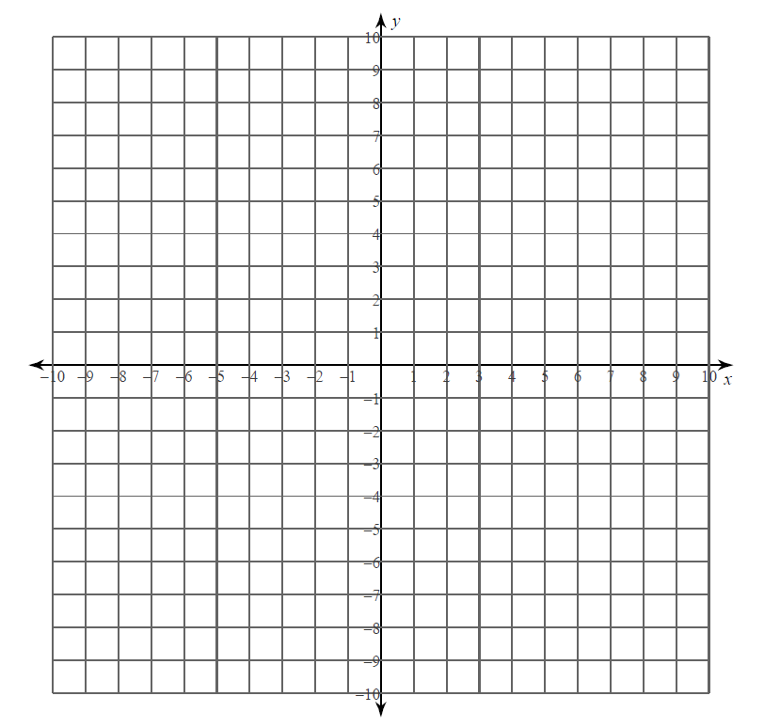 | 2. $f\left(x\right)=\sqrt{x}-4$  a = ______ h = ______ k = ______  Reflection? ______  Vertical stretch or shrink? ____________  Horizontal shift? ____________________  Vertical shift? _____________________
3. $f\left(x\right)= -\sqrt{x}+2$  a = ______ h = ______ k = ______  Reflection? ______  Vertical stretch or shrink? ____________  Horizontal shift? ____________________  Vertical shift? _____________________ | 4. $f\left(x\right)=\sqrt{x+1}-6$  a = ______ h = ______ k = ______  Reflection? ______  Vertical stretch or shrink? ____________  Horizontal shift? ____________________  Vertical shift? _____________________
5. $f\left(x\right)= 3\sqrt{x}-4$  a = ______ h = ______ k = ______  Reflection? ______  Vertical stretch or shrink? ____________  Horizontal shift? ____________________  Vertical shift? _____________________ | 6. $f\left(x\right)=-2\sqrt{x+3}$  a = ______ h = ______ k = ______  Reflection? ______  Vertical stretch or shrink? ____________  Horizontal shift? ____________________  Vertical shift? _____________________
7. $f\left(x\right)= -2\sqrt{x-1}-5$  a = ______ h = ______ k = ______  Reflection? ______  Vertical stretch or shrink? ____________  Horizontal shift? ____________________  Vertical shift? _____________________ | 8. $f\left(x\right)=\frac{1}{2}\sqrt{x+4}$  a = ______ h = ______ k = ______  Reflection? ______  Vertical stretch or shrink? ____________  Horizontal shift? ____________________  Vertical shift? _____________________
9. $f\left(x\right)= \sqrt[3]{x-2}$  a = ______ h = ______ k = ______  Reflection? ______  Vertical stretch or shrink? ____________  Horizontal shift? ____________________  Vertical shift? _____________________ | 10. $f\left(x\right)=\sqrt[3]{x}+4$  a = ______ h = ______ k = ______  Reflection? ______  Vertical stretch or shrink? ____________  Horizontal shift? ____________________  Vertical shift? _____________________
11. $f\left(x\right)=\sqrt[3]{ x+1}-6$  a = ______ h = ______ k = ______  Reflection? ______  Vertical stretch or shrink? ____________  Horizontal shift? ____________________  Vertical shift? _____________________ | 12. $f\left(x\right)= 3\sqrt[3]{x}$  a = ______ h = ______ k = ______  Reflection? ______  Vertical stretch or shrink? ____________  Horizontal shift? ____________________  Vertical shift? _____________________
13. $f\left(x\right)=-2\sqrt[3]{x}+1$  a = ______ h = ______ k = ______  Reflection? ______  Vertical stretch or shrink? ____________  Horizontal shift? ____________________  Vertical shift? _____________________ | 14. $f\left(x\right)= \frac{1}{2}\sqrt[3]{x-1}-4$  a = ______ h = ______ k = ______  Reflection? ______  Vertical stretch or shrink? ____________  Horizontal shift? ____________________  Vertical shift? _____________________
15. $f\left(x\right)= -\sqrt[3]{x-2}+3$  a = ______ h = ______ k = ______  Reflection? ______  Vertical stretch or shrink? ____________  Horizontal shift? ____________________  Vertical shift? _____________________ | 16. $f\left(x\right)=\sqrt[3]{x+2}-3$  a = ______ h = ______ k = ______  Reflection? ______  Vertical stretch or shrink? ____________  Horizontal shift? ____________________  Vertical shift? _____________________

