Unit 4B: Graphing Rational Functions
- Identify the important features of rational functions…
  - x- and y-intercepts
  - vertical, horizontal and/or slant asymptotes
  - holes
  - domain and range
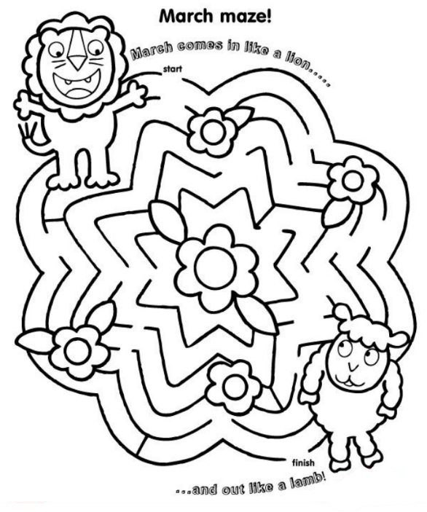
- Graph rational functions

Monday | Tuesday | Wednesday | Thursday | Friday
22 day 1  Holes, Asymptotes, & Intercepts  CW: p. 1-3 (no graphing)  HW: p. DeltaMath (closes at midnight) | 23 day 2  Graphing Rational Functions  CW: p. 2-3 (graphs)  HW: p. 4-5 | 24 day 3  Graphing Rational Functions with Slant Asymptotes  CW: p. 6 & start Desmos activity  HW: Finish Desmos activity by midnight | 25 day 4  Graphing Practice  CW: p. 7-8  HW: DeltaMath Skills Check | 26  Asynchronous Learning Day  Help Session at 11:00-12:00  DeltaMath Skills Check due by Sunday at 11:59 PM
29 day 5  Review  CW: p. 9  HW: p. 10-13  Upload Week 11/12 HW to CTLS by Monday at 11:59 PM (p. 4-5 & 10-13) | 30 day 6  Unit 4A Test  (During class or live session with video ON) | 31  Asynchronous Learning Day  Help Session by Appointment | 32 | 33
*THIS PLAN IS SUBJECT TO CHANGE. PLEASE REFER TO CTLS DIGITAL CLASSROOM FOR UPDATES.*

