**Unit 8**

**Integration Applications**

Topics Covered:

* Average Function Value & Mean Value Theorem
* Area Between 2 Curves
* Volume by Known Cross Sections
* Volumes of Revolutions – Disk & Washer Method

Quiz is ______________

Test is ______________

Name: ________________

Average Function Value/Mean Value Theorem

For each problem, find the average value of the function over the given interval.

|  |  |  |  |
| --- | --- | --- | --- |
| 1. | $f\left(x\right)=-x^{2}-2x+5; \left[-4, 0\right]$ | 2. | $f\left(x\right)=-x^{4}+2x^{2}+4; \left[-2, 1\right]$ |
| 3. | $f\left(x\right)=4-x^{2}; [-2, 2]$ | 4. | $$f\left(x\right)=\frac{x^{2}+5}{x};[1, 2]$$ |
| 5. | $f\left(x\right)=\sin{x}; [0,π]$ | 6. | $f\left(x\right)=\cos{x}; \left[0,\frac{π}{2}\right]$ |

**For each problem, find the values of c that satisfy the Mean Value Theorem for Integrals.**

|  |  |  |  |
| --- | --- | --- | --- |
| 7. | $$f\left(x\right)=-x+2; \left[-2, 2\right]$$ | 8. | $f\left(x\right)=\frac{4}{x^{2}}; \left[-4,-2\right]$ |
| 9. | $f\left(x\right)=4\sqrt{x}; [0,4]$ | 10. | $f\left(x\right)=-3{\left(2x-6\right)}^{\frac{1}{2}}; \left[3, 5\right]$ |

**Area Between Curves Introduction Worksheet**

Draw the arbitrary rectangle and set up the integral to find the area for the shaded region.

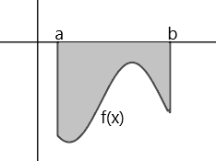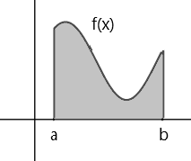

1. 2.

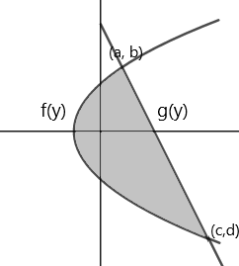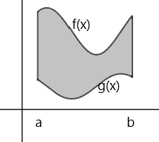

3. 4.

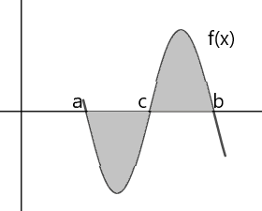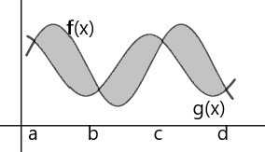5. 6.

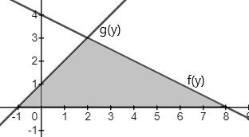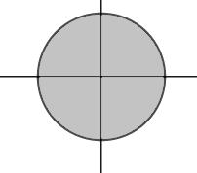

7. 8.

**Area between Two Curves**

Compute the area of the shaded region.

|  |  |
| --- | --- |
| 1. |  |
| 2. |  |
| 3. |  |

**Compute the area of the region enclosed by the given curves.**

|  |  |  |  |
| --- | --- | --- | --- |
| 4. | $y=4x, y=6x^{2}$ | 5. | $y=2x^{2}, y=x^{2}+2$ |
| 6. | $x=4-y^{2}, x=y^{2}-4$ | 7. |  |

**Area between Curves 2**

**Find the area of the shaded region analytically.**

|  |  |  |  |
| --- | --- | --- | --- |
| 1. |  | 2. |  |
| 3. |  | 4. |  |
| 5. |  | 6. |  |
| 7. | Find the area of the region(s) enclosed by the graphs of $x-y^{2}=0$ and $x+2y^{2}=3$ | 8. | Find the area of the region(s) enclosed by the graphs of $y=x^{2}$ and $y=-x$ from $x=0$ to $x=3$ |

**Volumes with Cross Sections**

1. The base of a solid is bounded by , the x-axis, and the y-axis. Cross sections that are perpendicular to the x-axis are isosceles right triangles with the right angle on the x-axis. (Legs perpendicular to the x-axis). Find the volume.

2. The base of a solid is bounded by the semi-circle  & the x-axis. Cross sections that are perpendicular to the x-axis are squares. Find the volume.

3. The base of a solid is bounded by  , the positive x-axis & the positive y-axis. Cross sections that are perpendicular to the y-axis are isosceles right triangles. Find the volume.

4. The base of a solid is a circular region in the xy-plane bounded by the graph . Find the volume of the solid if every cross section by a plane normal to the x-axis is a semi-circle.

5. The base of a solid is circular region in the xy-plane bounded by the graph of . Find the volume of the solid if every cross section by a plane normal to the x-axis is a square with one side as the base.

6. The base of a solid is bounded by , the x-axis, and the y-axis. Cross sections that are perpendicular to the y-axis are semi-circles. Find the volume.

**Find the Volumes of Revolution: Disk Method**

|  |  |  |  |  |
| --- | --- | --- | --- | --- |
| 1. | $y=\sqrt{x}, x=1, x=4, y=0$ about the x-axis |  | 2. | $y=-x+1, y=0, x=0$ about the x-axis |
| 3. | $y=4-x^{2},y=0, x=0,$ (in the 1st quadrant) about the x-axis |  | 4. | $y=x^{2},x=0, y=4,$ (in the 1st quadrant) about the y-axis |
| 5. | $y=\sqrt{4-x^{2}},y=0, x=0,$ (in the 1st quadrant) about the x-axis |  | 6. | $x=4y-y^{2}, y=1, x=0,$ about the y-axis |
| 7. | $y=x^{\frac{2}{3}}, y=1, x=0,$ about the y-axis |  | 8. | $y=5x-x^{2}, y=0,$ about the x-axis |

**Find the Volumes of Revolution: Washer Method**

|  |  |  |  |
| --- | --- | --- | --- |
| 1. | $f\left(x\right)=2\sqrt{x} and g\left(x\right)=x^{2}$ about the x-axis | 2. | $f\left(x\right)=2\sqrt{x} and g\left(x\right)=x^{2}$ about the y-axis |
| 3. | $y=x^{2}+1,y=1,x=1, x=0$ about the y-axis | 4 | $y=\frac{1}{x}, y=2, and x=2$ about the y-axis |
| 5. | $y=x, y=2-x^{2}, and x=0$ about the x-axis | 6. | $y=x^{2} and y=2x,$ about the y-axis |
| 7. | $y=x^{2}, and y=x+2,$ about the $x-axis$ | 8. | $y=2x+2 and y=x^{2}+2$ about the x-axis |

**Unit 7 Integration Applications Review**

**Find the average value of the function over the interval:**

|  |  |  |  |
| --- | --- | --- | --- |
| 1. | $f\left(x\right)=\frac{1}{\sqrt{x-1}} [5,10]$ | 2. | $f\left(x\right)=x^{3} [0,2]$ |

**Find the value of c guaranteed by the Mean Value Theorem:**

|  |  |  |  |
| --- | --- | --- | --- |
| 3. | $f\left(x\right)=-2x+1 [0, 4]$ | 4. | $f\left(x\right)=\frac{2}{x^{2}} [2, 4]$ |

**Determine the area of the bounded region:**

|  |  |  |  |
| --- | --- | --- | --- |
| 5. | $y=\frac{1}{x^{2}}, y=0, x=1, x=5$ | 6. | $x=y^{2}-2y, x=3$ |
| 7. | $y=x, y=x^{3}$ | 8. | $x=y^{2}+1, x=y+3$ |
| 9. | $y=\sin{x}, y=\cos{x},\frac{π}{4}≤x≤\frac{5π}{4}$ | 10. | $y=x^{2}+1, y=-x+7, x=0$ |
| 11. | $$y={5x- x}^{2}, y=x$$ | 12. | $$x=y^{2}-4y, x=2y-y^{2}$$ |

**Find the volume by cross sections:**

13. The base of a solid is the region enclosed by the circle $x^{2}+y^{2}=16$. If cross sections are built up perpendicular to the x-axis, find the volume of the solid created if the cross sections are:

a) squares

b) isosceles right triangles set on the hypotenuse

c) What if cross sections are perpendicular to the y-axis and are semi-circles?

14. The base of a solid is the region between y = 4 – x2 , x=0, y=0. If cross sections are perpendicular to the y-axis and are semicircles, find the volume.

15. Find the volume of the region generated by $y=\sqrt{25-x^{2}}$ and the x-axis. The cross sections are perpendicular to the x-axis:

|  |  |  |  |  |  |
| --- | --- | --- | --- | --- | --- |
| a. | Squares | b. | Isosceles triangles | c. | Semi Circles |

16. Find the volume of the region generated by $y=\frac{1}{\sqrt{x}}, x=0, x=4, y=1 \& y=3.$ The cross sections are perpendicular to the y-axis:

|  |  |  |  |  |  |
| --- | --- | --- | --- | --- | --- |
| a. | Squares | b. | Isosceles triangles | c. | Semi Circles |

17. Find the volume of the region generated by $y=-\frac{x^{2}}{9}+4 and y=0$. The cross sections are perpendicular to the x-axis. The cross sections are rectangles with a height twice the base.

**Find the volume of the revolution.**

Draw the graph, draw the arbitrary cross section, set upthe integral, & find the volume.

18. , y = 0, x = 0 and x = 2

a. about the x axis.

b. about the y-axis:

19. $y=x^{2}, x=0, y=4$

a. about the x-axis.

b. about the y-axis.

Find the volume of the solid generated by revolving the plane region bounded by the indicated equations:

20. $y=x, y=0, x=4$

1. x-axis
2. y-axis

21. $y=\sqrt{x}, y=2, x=0$

1. x-axis
2. y-axis

22. about the x-axis