Unit 2 Polynomials: Review – Characteristics of Polynomials
Identify the characteristics for the following polynomials:
- f(x)= -x³ – 2x⁴ + x + 3

Standard form ____________________ Leading Coefficient ________ Degree ________

# of Zeros ______ Classify by degree ______________ Classify by # of terms _________________

End Behavior: as x → +∞, f(x) → __________ as x → - ∞, f(x) → __________ # of Turns ______

- f(x)= 3x - 5 + x²

Standard form ____________________ Leading Coefficient ________ Degree ________

# of Zeros ______ Classify by degree ______________ Classify by # of terms _________________

End Behavior: as x → +∞, f(x) → __________ as x → - ∞, f(x) → __________ # of Turns ______

- f(x)= 4x

Standard form ____________________ Leading Coefficient ________ Degree ________

# of Zeros ______ Classify by degree ______________ Classify by # of terms _________________

End Behavior: as x → +∞, f(x) → __________ as x → - ∞, f(x) → __________ # of Turns ______

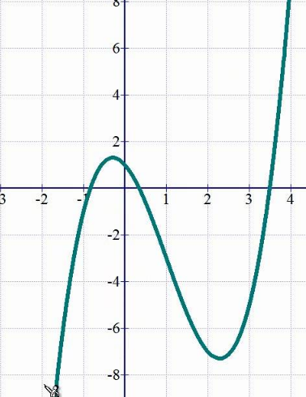
4.

Domain _______________
Range ___________________
Zero(s) __________________
Y-intercept _______________
# of Extrema _____________
Relative Maximum _________
Relative Minimum ___________
Absolute Maximum ___________
Absolute Minimum ____________
Int. of Increasing ______________
Int. of Decreasing ____________
End Behavior:
as x → +∞, f(x) → ________
as x → - ∞, f(x) → ________
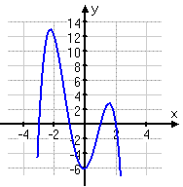
5.

Domain _______________
Range ___________________
Zero(s) __________________
Y-intercept _______________
# of Extrema _____________
Relative Maximum _________
Relative Minimum ___________
Absolute Maximum ___________
Absolute Minimum ____________
Int. of Increasing ______________
Int. of Decreasing ____________
End Behavior:
as x → +∞, f(x) → ________
as x → - ∞, f(x) → ________

